McDONALD, James Grover, American foreign policy expert and League of Nations High Commissioner for Refugees Coming from Germany 1933-1935, was born 29 November 1886 in Coldwater, Ohio and died 26 September 1964 in White Plains, New York, United States. He was the son of Kenneth McDonald, hotel manager, and Hannah Diederick. On 25 October 1915 he married Ruth Jane Stafford, teacher. They had two daughters.

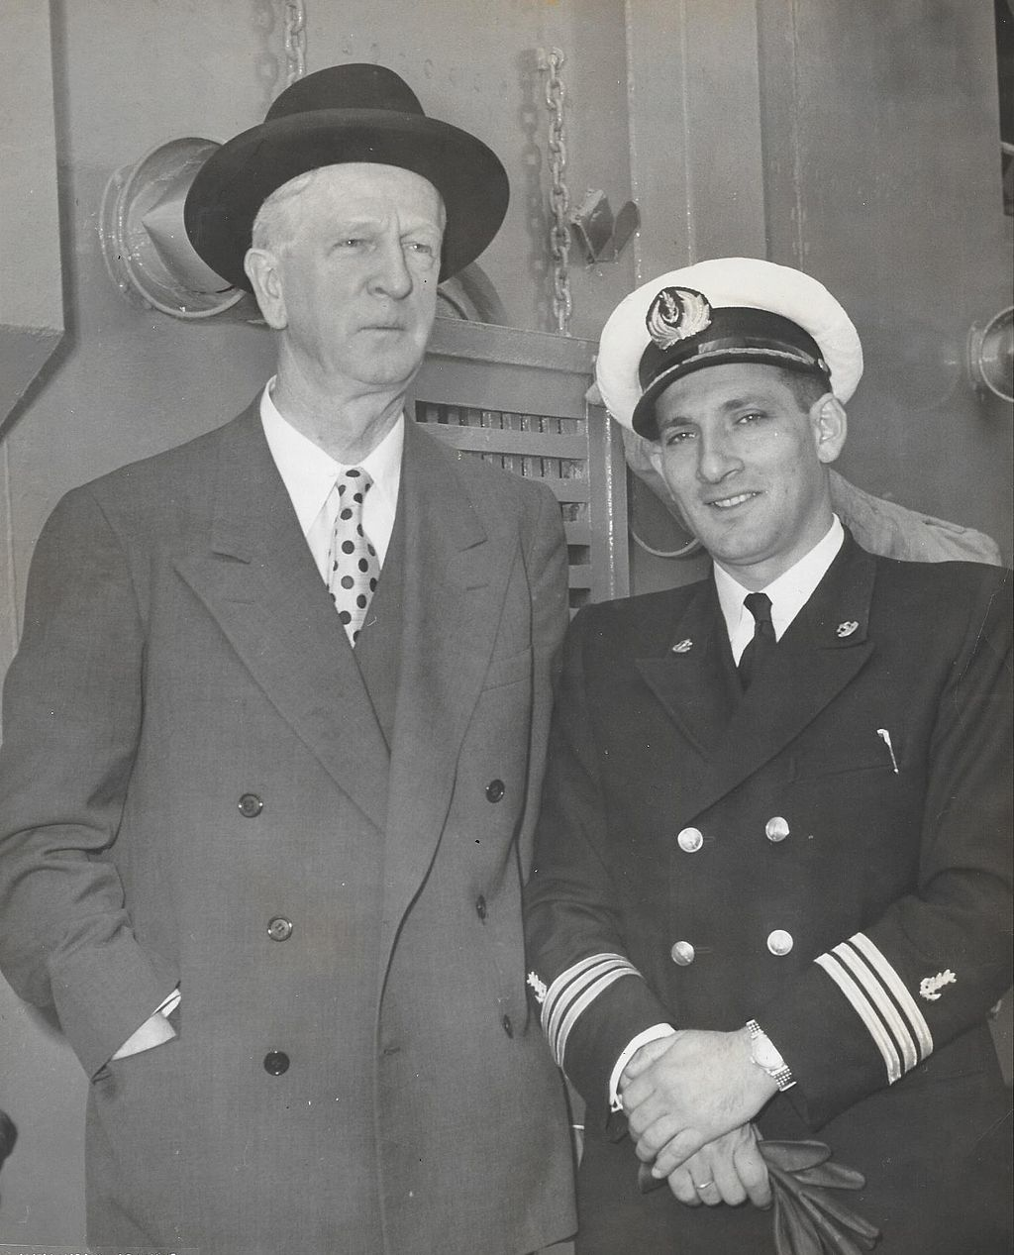
Source: https://commons.wikimedia.org/wiki/Category:James_Grover_McDonald#/media/File:ShErlJmMcDnld.jpg
On film: https://archive.org/details/gov.archives.arc.95754, Longines Chronoscope, 12 May 1952.

McDonald, the third of five brothers, received his secondary school diploma in 1905 in Albany, Indiana where his father owned a small hotel. Before going to Indiana University in Bloomington to study history, he worked in another hotel for one year. He received his Bachelor degree in 1909 and his Master’s degree a year later. After teaching history at Indiana University for one year he enrolled in a doctorate programme at Harvard University, where he remained until 1914, when he returned to Indiana University to become assistant professor of history and political science. Feeling that Germany was unfairly singled out as the prime originator of the war in Europe, he published a pamphlet in 1914 arguing that most of the charges made by Belgium and others about German atrocities were false or exaggerated and that Germany’s violation of Belgian neutrality was justified by Germany’s need for self-prevention. After a long engagement he married Ruth Stafford in 1915. Since the McDonalds were Catholic and the Staffords strict Methodists, a Catholic priest performed the wedding ceremony with the McDonald family present and a Methodist minister officiated a second ceremony for the Stafford family later that day. A fellowship from Harvard to conduct research for a year in France and Spain was also used for a long honeymoon in Spain. McDonald resumed his work at Indiana University in 1916, but did not finish his doctoral dissertation about an obscure sect of Spanish monks as he came to realize that no one would be interested in the topic. In 1917 he strongly advocated American entrance into the First World War, given Germany’s unrestricted submarine warfare in the Atlantic, but he became unhappy with the terms of the Treaty of Versailles, later believing that it had placed a burden on the new German republic and contributed to Weimar’s political collapse.
In 1918 McDonald resigned from Indiana University, due to the fact that he could not successfully negotiate a raise (a daughter had been born so he had greater financial need) and also to protest what he regarded as the arbitrary dismissal of a colleague. He moved to New York City, where he accepted a better paying job with the National Civil Service Reform League. In January 1919 he changed jobs and was named chairman of the League of Free Nations Association, which campaigned for the United States (US) to join the League of Nations. Although McDonald belonged to the moderates within the association (Abbott 1983: 488), its campaigns to secure US recognition of the revolutionary governments of Mexico and Russia brought him trouble. He had to appear before a Senate subcommittee, where he could not substantiate the claim that the US planned to intervene in Mexico. In addition, the Department of State, which had already placed him on a list of unpatriotic American professors during the war, charged him for releasing sensitive documents relating to US policy toward Russia for which no clearance was received. McDonald, who had written the foreword to the publication, then guided the association in its transition from an activist organization to an educational one, aimed at promoting greater understanding of foreign affairs. In 1922 the name was changed to Foreign Policy Association (FPA), which published background studies and a bulletin, organized discussion meetings and secured radio coverage of its activities. Through this work McDonald developed good relations with American liberal internationalists such as Joseph P. Chamberlain and Paul Kellogg, conservative businessmen such as John D. Rockefeller Jr., who was also one of the largest contributors to the association, and international lawyers such as John Foster Dulles. In connection with his work McDonald travelled to various locations in Europe almost every year, most frequently to Geneva, where he became acquainted with foreign politicians in the League of Nations, American diplomats and members of the press. He also served with the Commission for International Justice and Good Will of the Federal Council of Churches of Christ in America. Although Catholic by origin, he attended a variety of Protestant services and studied the Bible, but, according to his daughter (in Breitman et al. 2007: 6), mainly from a historical point of view. He became interested in Judaism in its different forms, admiring the Jewish people through the ages.
McDonald visited Germany for the FPA several times and gained a closer understanding of the objectives of the Nazi movement. In 1932 he observed Adolf Hitler at a public meeting and in April 1933 had an appointment with him arranged through Putzi Hanfstaengl, his contact in Nazi circles who knew of his past sympathy for Germany. This was followed by a visit to the concentration camp at Dachau in September, where he noticed fear in the eyes of the political prisoners who were being ‘educated’ (Breitman et al. 2007: 97). In April 1933 McDonald informed US President Franklin Delano Roosevelt, who was considering a new ambassador to Germany, about the situation in the country. McDonald, who had already thought about the possibility of becoming US representative to the League of Nations in November 1932, was interested in the post of ambassador in Berlin, but lost out to William E. Dodd, who was nominated in June. Although disappointed, McDonald was now freer to express his views on the Nazi regime. In his weekly radio broadcasts he constantly emphasized that the Nazis threatened not just Jews, but also civilization and world peace. McDonald also became part of a lobby for League of Nations action. Mildred Wertheim, the FPA’s resident expert on Germany, had the idea to elicit League interest in an organization to assist refugees from Germany. She convinced Arthur Sweetser in the League Secretariat and Chamberlain to join a lobbying effort, while Ernst Feilchenfeld of the American Jewish Congress worked to win the support of American and British Jewish organizations. They initiated a draft petition to the League to re-establish the office of High Commissioner for Refugees and tasked McDonald to seek governmental support for a formal proposal. McDonald talked with the head of the League’s Nansen International Office for Refugees, which had a restricted mandate, and with the Secretary-General of the League of Nations, Joseph Avenol, who showed interest but insisted upon avoiding any opposition from Germany and also assumed that finances should come from outside the League. McDonald lobbied several governments willing to support the proposed High Commissioner. German pressure in Geneva resulted in weakening the envisaged institution, as it became an autonomous organization, dealing only with refugees already outside Germany, receiving no financial support from the League and not reporting to the League, but to its own Governing Board. The Second Committee approved the modified resolution on 10 October 1933 and the Assembly provided its support on 12 October. The Council then instructed Avenol and five countries that had supported the proposal to appoint a High Commissioner. James Rosenberg of the American Jewish Distribution Committee had already suggested McDonald. The Department of State refused to become involved, but the British government, which had kept Palestine outside of the High Commissioner’s jurisdiction, was glad to have an American involved. On 25 October the committee appointed McDonald as High Commissioner for Refugees Coming from Germany. McDonald emphasized that his job was to supplement and make more efficient the work being done, not to displace the efforts already in place (Breitman et al. 2007: 141).
Avenol told McDonald that the autonomous High Commissioner’s site could not be in Geneva (it became based in Lausanne) and, since McDonald was not a League official, Avenol could not supply official papers for him. Instead, the Governing Board, composed of 15 states (those involved in creating the office of High Commissioner plus Germany’s neighbouring states), did this. McDonald appointed Norman Bentwich as his deputy, who worked with local Jewish communities and refugee organizations in European countries to coordinate relief and seek prospects for admission and permanent settlement. The private organizations, which were the main source of funds, were grouped in an Advisory Committee. McDonald’s fundraising strategy among Jewish organizations involved bringing Zionists and non-Zionists together, which was often difficult and frustrating. The Governing Body included few refugee experts and, according to Bentwich, they ‘wanted to do as little as possible about the cause’ (quoted in Orchard 2014: 124). Even the exceptions, such as Chamberlain and chair Robert Cecil, still accepted the consensus that Europe as a whole could not support further refugees. McDonald, who succeeded in obtaining direct access to foreign statesmen, was convinced that the only way to deal with the refugee issue was to influence the domestic politics of the countries causing the movements, but most politicians did not act upon his strategy of putting pressure on Nazi Germany. He repeatedly visited Germany, trying to facilitate Jewish emigration, but was successful only once in an emigration arrangement to Palestine in exchange for German exports there. Overseas migration was tried as well, but no state was prepared to finance this and the effort remained restricted to placing a small number of scholars who were refugees in Brazil. McDonald also attempted to loosen US immigration regulations, but was met with lack of support from the Department of State, which expressed concern about increasing anti-Semitic sentiment in the US and, therefore, blocked a small immigration arrangement supported by Roosevelt. The situation within the League of Nations became complicated in May 1935, when the Council entrusted the protection of Saar refugees to the Nansen International Office rather than the High Commissioner. An effort in June by the Norwegian government, backed by private organizations, to centralize the League’s refugee work was rejected. Although it was estimated that the High Commissioner cared for some 100,000 persons at an expenditure of 25 million US dollars, McDonald reached the conclusion that there was no more he could do as High Commissioner. He decided to resign in a way that would draw attention to the cause. On 27 December 1935 he resigned publicly with a lengthy open letter, which was widely published, arguing that the conditions in Germany had developed so catastrophically that the League needed to reconsider the entire situation.
In 1936 McDonald returned to the US, where he joined the editorial staff of The New York Times. In the spring of 1938 he became director of the Brooklyn Institute of Arts and Sciences, which left him freer to speak about refugee issues. He had followed events in Germany and was elected chair of President Roosevelt’s new Advisory Committee on Political Refugees in May. Worried about the increasing number of Jewish refugees after the Austrian Anschluss of March 1938, Roosevelt had launched an initiative, without consulting the Department of State, which resulted in a conference in Evian, France in July and the establishment of the Inter-Governmental Committee of Refugees (IGCR) separate from the League of Nations. McDonald attended the Evian conference and advised Roosevelt afterwards, but negotiations between the IGCR and German Economics Minister Hjalmar Schacht on Jewish emigration and Roosevelt’s plan for resettling refugees in underdeveloped areas (only Bolivia and the Dominican Republic responded positively) remained unsuccessful, while the Department of State sustained its strict immigration rules. In 1940 Roosevelt moved away from humanitarian action and all McDonald and the Advisory Committee could do was work on small numbers of individual cases. McDonald left the Brooklyn Institute in January 1942 and joined the staff of the National Broadcasting Company, where he commented on the news in The-World-To-Day-programme until 1944.
McDonald had concluded by this point that Palestine should be opened to Jewish immigration. Although his connections in Washington DC had diminished after Roosevelt’s death in April 1945, he lobbied successfully to become a member of the Anglo-American Committee Regarding the Problems of European Jewry and Palestine in January 1946. He actively sought out the opinions of all groups and disagreed strongly with the British, mostly behind closed doors and not in public hearings. The Committee’s report, released in late April, recommended the immediate admission of 100,000 additional Jewish refugees, which McDonald believed was insufficient since he thought that Holocaust survivors should not be kept in displaced persons camps. He tirelessly advocated the report’s implementation and visited Palestine again in 1947. When the United Kingdom turned to the United Nations (UN) for a solution, he remained involved, although the Department of State would not allow him near the US delegation or the UN Special Committee on Palestine. The de facto recognition of the newly proclaimed State of Israel by the US was followed by an agreement for an exchange of envoys and in June 1948 President Harry S Truman appointed McDonald as special representative, over the opposition of the Department of State. In March 1949 he was appointed as Ambassador. He retired in December 1950 and returned to New York City, where he wrote a memoir of his time in the Middle East, was a member of the Harvard Club of New York and chaired the Israel Bonds Organization, which helped Israel raise funds for immigrant absorption, until his death in 1964. In 2003 the US Holocaust Memorial Museum received an unsolicited donation of a part of his diaries, which resulted in the publication of his diaries and papers dating from 1932 to 1947, in three volumes between 2007 and 2015, with a fourth volume planned.
Remarkable in the life of this US foreign policy expert is that his early radical period (his war pamphlet and positions in the early 1920s) caused a lifelong troubled relationship with the Department of State, which, however, had to twice accept McDonald as a diplomat. McDonald’s expertise on events in Nazi Germany and his contacts in League of Nations circles coincided with a temptation to become a diplomat. Notwithstanding his awareness of the small room for manoeuvre he was willing to become High Commissioner for Refugees Coming from Germany. When McDonald’s leeway proved even narrower, he caused a shock by publicly resigning. He continued his activities for refugees in US government circles, engaged in the Palestine issue and became the first American ambassador to Israel. Both his resignation and ambassadorship are still mentioned in historical publications.

ARCHIVES: James G. McDonald papers, 1838-1972 (Bulk Date: 1914-1962) in Archival Collections Columbia University Libraries, New York, see www.columbia.edu/cu/lweb/archival/collections/ldpd_4078520/; the United States Holocaust Memorial Museum in Washington DC holds the originals of his published diaries.
PUBLICATIONS: German ‘Atrocities’ and International Law, Chicago 1914; Soviet Union, New York 1927; America’s Stake in Europe, New York 1930; Latin America, Chicago 1931; Letter of Resignation of James Grover McDonald, High Commissioner for Refugees (Jewish and Other) Coming from Germany, Addressed to the Secretary General of the League of Nations. With an Annex Containing an Analysis of the Measures in Germany against ‘Non-Aryans’, and of their Effects in Creating Refugees, London 1935; Palestine, A Jewish Commonwealth in Our Time, Washington DC 1943 (with others); ‘Refugees’ in H.E. Davis (Ed.), Pioneers in World Order: An American Appraisal of the League of Nations, New York 1944, 208-228; My Mission in Israel 1948-1951, London 1951; R. Breitman, B. McDonald Stewart and S. Hochberg (Eds), Advocate for the Doomed: The Diaries and Papers of James G. McDonald 1932-1935, Bloomington 2007; R. Breitman, B. McDonald Stewart and S. Hochberg (Eds), Refugees and Rescue: The Diaries and Papers of James G. McDonald 1935-1945, Bloomington 2009; N.J.W. Goda, R. Breitman, B. McDonald Stewart and S. Hochberg (Eds), To the Gates of Jerusalem: The Diaries and Papers of James G. McDonald 1945-1947, Bloomington 2015.
LITERATURE: Christian Science Monitor, 2 January 1935, 11; New York Times, 26 February 1949, 7; ‘McDonald, James G(rover)’ in A. Rothe (Ed.), Current Biography 1949, New York 1950, 373-375; L.W. Holborn, The International Refugee Organization: A Specialized Agency of the United Nations. Its History and Work 1946-1952, London 1956; New York Times, 27 September 1964, 86; H. Genizi, James McDonald and the Roosevelt Administration, Ramat Gan 1978; F.W. Abbott, ‘McDonald, James Grover’ in W.F. Kuehl (Ed.), Biographical Dictionary of Internationalists, Westport 1983, 488-490; M.R. Marrus, The Unwanted: European Refugees in the Twentieth Century, New York 1985; G. Loescher, The UNHCR and World Politics: A Perilous Path, Oxford 2001; D.R. Laffer, The Jewish Trail of Tears: The Evian Conference of 1938, Tampa 2011 (Master thesis University of South Florida, available at http://scholarcommons.usf.edu/cgi/viewcontent.cgi?article=4390& context=etd); M. Housden, The League of Nations and the Organisation of Peace, Harlow 2012; Ph. Orchard, A Right to Flee: Refugees, States, and the Construction of International Cooperation, Cambridge 2014; S. Eshel, A Voice Among the Silent: The Legacy of James G. McDonald. A Film, 2015 (all websites accessed on 7 January 2016).

Bob Reinalda

Version 26 January 2016

How To Cite This IO BIO Entry?
Bob Reinalda, ‘McDonald, James Grover’ in IO BIO, Biographical Dictionary of Secretaries-General of International Organizations, Edited by Bob Reinalda, Kent J. Kille and Jaci L. Eisenberg, www.ru.nl/fm/iobio, Accessed DAY MONTH YEAR

